**Constant features**

Constant features are those that show the same value, just one value, for all the observations of the dataset. This is the same value for all the rows of the dataset. These features provide no information that allows a machine learning model to discriminate or predict a target.

Identifying and removing constant features, is an easy first step towards feature selection and more easily interpretable machine learning models.

**Quasi-constant features**

Quasi-constant features are those that show the same value for the great majority of the observations of the dataset. In general, these features provide little if any information that allows a machine learning model to discriminate or predict a target. But there can be exceptions. So you should be careful when removing these types of features.

**Steps to remove Quasi - Constant Features**

In this section, we will create a quasi-constant filter with the help of VarianceThreshold function.

To do so we will use the VarianceThreshold function. The function requires a value for its threshold parameter.

Variance threshold from sklearn is a simple baseline approach to feature selection. It removes all features which variance doesn’t meet some threshold.

Step 1 : Execute the following script to import the desired libraries:

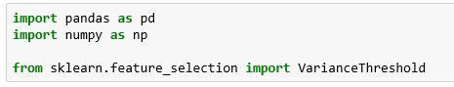

Step 2 : Execute the following script to drop the Quasi - Constant Columns

Following is the line by line explanation about the code :

a). In Line 1, we created our Quasi-Constant filter using VarianceThreshold and set the Threshold value as 0.01.

Instead of passing 0 as the value for the threshold parameter, we are passing 0.01, which means that if the variance of the values in a column is less than 0.01, remove that column.

In other words, remove the feature column where approximately 99% of the values are similar.

b). In Line 2, We applied the filter to our training set using fit()

c). In Line 4, we will check the number of our non-quasi-constant columns.

“qconstant_filter.get_support()” gives the number

